When Seconds Matter: Predicting Dispatch Response Time
in Montgomery County (2025)
Lucjan Szulim • DATA 205 • Prof. Alraee • May 2025

1. Introduction
When a resident of Montgomery County calls 911, how long does it take for an officer to arrive, and what determines that wait? Dispatch response time is a measure of both operational efficiency and public safety equity. Longer response times for lower-priority or geographically disadvantaged calls can have real consequences for community safety outcomes.
This project analyzes 252,157 police dispatch incidents and 59,811 crime reports from Montgomery County’s open data portal, all filtered to 2025. The main goal is to identify the most significant predictors of dispatch response time, defined as the time from dispatch to recorded arrival. Secondary goals include linking crime type to dispatch behavior and understanding whether geographic and time-based factors independently affect response speed.

2. Data & Methods

2.1 Datasets
The two datasets were sourced from the Data Montgomery Open Data Portal and filtered to only 2025 records. The Police Dispatched Incidents dataset (252,157 records) contains incident timestamps, priority levels (0–4), initial and close incident types, geographic identifiers (district, beat, PRA), and six time-interval columns measured in seconds. The Crime Reports dataset (59,811 records) contains offense codes, crime categories, and geographic coordinates. The two datasets share district, beat, and PRA identifiers, enabling geographic joins.

2.2 Data Cleaning & Feature Engineering
All cleaning and feature engineering was performed in a dedicated ingestion colab notebook.
Important cleaning decisions:
- Response times greater than 120 minutes were removed (n = 415, 0.16%) as they were extreme outliers skewing the data. A response time of over 2 hours is unlikely in an emergency.
- Response times under 1 minute were excluded as they were likely representing calls where an officer was already on scene.
- 59,011 calls with no recorded officer arrival were flagged separately and excluded from response time analysis. This is a limitation of this data.
- Over 20 features were engineered, including cyclic hour encoding (sin/cos), time-of-day buckets, priority labels, broad incident categories, weekend indicator, and district-level crime density.

The final analytic population for response time analysis comprised 192,731 dispatch calls.

2.3 Analytical Pipeline
Analysis proceeded in three stages. Exploratory data analysis (EDA) explores distributions, time-based patterns, and relationships between datasets. Six hypothesis tests were then conducted using non-parametric methods appropriate for the right-skewed response time distribution, with Bonferroni correction applied to all post-hoc tests and effect sizes reported alongside p-values. Finally, two model families, OLS regression and Random Forest, were fit on both raw and log-transformed response time, with the log-transformed Random Forest identified as the best-performing model.

3. Exploratory Data Analysis (EDA)
Response time followed a right-skewed, approximately log-normal distribution with a median of 7.95 minutes and a mean of 11.29 minutes (SD = 12.28 min). The distribution confirmed that non-parametric statistical tests and log-transformation for modeling were appropriate. Kruskal-Wallis tests confirmed statistically significant differences by priority (H=2,911, p<0.001), incident category (H=540, p<0.001), and time of day (H=721, p<0.001).
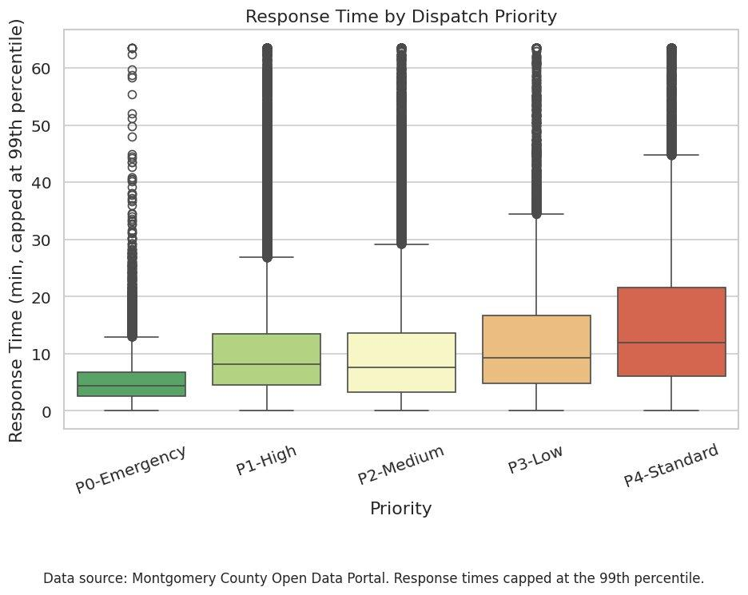
Figure 1. Response time by dispatch priority level (capped at 99th percentile). P0-Emergency median: 4.6 min; P4-Standard median: 13.6 min.
Figure 1 shows the dominant role of priority level. P0-Emergency calls had a median response of 4.6 minutes, compared to 13.6 minutes for P4-Standard, nearly a 3x difference. Notably, P1-High and P2-Medium boxes visually overlap, a pattern confirmed statistically by Dunn post-hoc testing (p=1.0), suggesting these two priority levels receive operationally equivalent dispatch urgency.
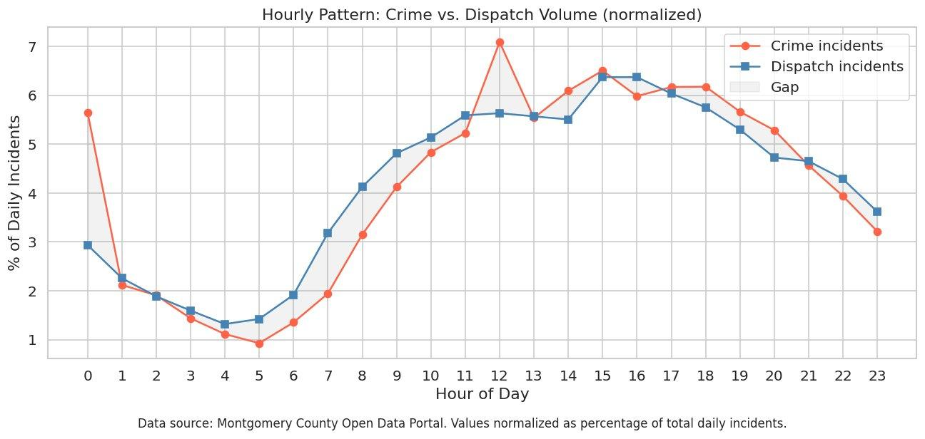
Figure 2. Hourly crime and dispatch volume, normalized as a percentage of the daily total. Crime and dispatch track closely through most of the day; late-night hours show relatively higher crime volume relative to dispatch.
Figure 2 reveals strong alignment between crime and dispatch volumes across the day, with both peaking in the early afternoon and reaching a minimum around 4-5 am. A notable spike in crime volume at noon (hour 12) is not matched by dispatch volume, suggesting some midday crimes are reported retrospectively rather than in real time. Both series rise sharply from 6 am onward, reflecting the daily activity of commuters.
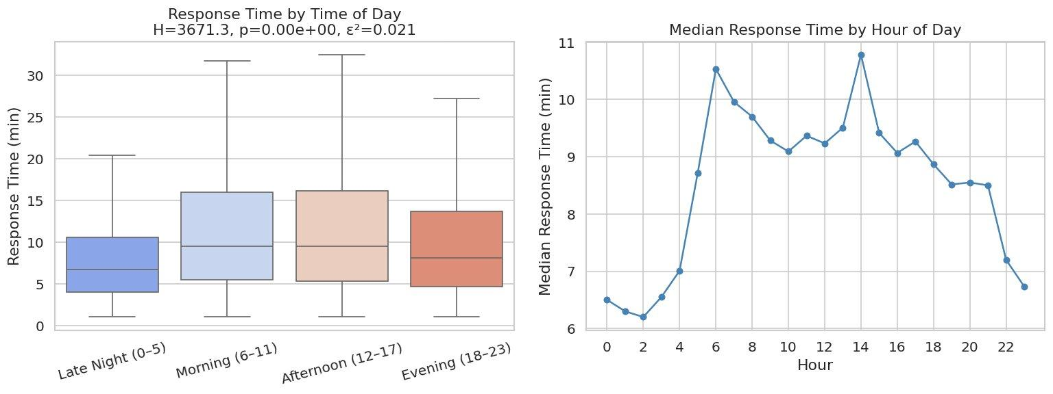
Figure 3. Response time by time-of-day bucket (left) and by individual hour (right). Late-night hours (midnight–5 am) have the fastest median response at 6.5 minutes; morning and afternoon are slowest at approximately 9.8 minutes.
Figure 3 shows that late-night calls receive substantially faster responses than daytime calls, a finding explained by lower call volume rather than increased overnight staffing. Morning and afternoon periods were statistically indistinguishable from each other (Dunn post-hoc p=0.327) but both significantly slower than late night (p<0.001).
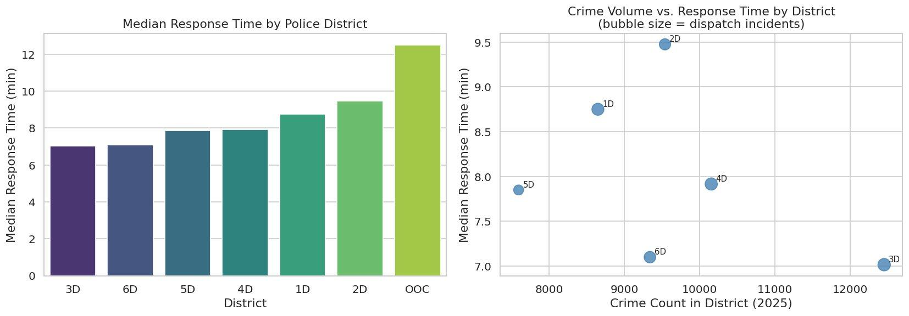
Figure 4. Median response time by police district (left) and crime volume vs. response time scatter by district (right, bubble size = dispatch incidents). Districts 3D and 6D respond fastest; OOC (Out of County) is excluded from analysis.
Figure 4 shows meaningful geographic variation, with Districts 3D (Silver Spring) and 6D (Montgomery Village) achieving the fastest median response times (approximately 7.0 minutes) compared to Districts 1D (Rockville) and 2D (Bethesda) (approximately 8.7–9.5 minutes). Importantly, the scatter plot shows no clear positive relationship between crime volume and response time at the district level. Districts 3D and 6D have among the highest crime counts yet the fastest responses, suggesting heavier officer deployment in high-crime areas.

4. Statistical Tests
Six hypothesis tests were conducted on the analytic dataset (n = 192,731). All tests used non-parametric methods due to the right-skewed response time distribution. Effect sizes are shown to distinguish statistical significance from practical significance, critical at this sample size, where even trivially small differences will be statistically significant.

Test | Method | Result | Effect Size | Reject H₀
RT by priority | Kruskal-Wallis + Dunn | H=2911, p<0.001 | ε²=0.104 (medium) | Yes
RT by incident category | Kruskal-Wallis + Dunn | H=540, p<0.001 | ε²=0.019 (small) | Yes
Weekend vs. weekday | Mann-Whitney U | p<0.001 | r=−0.053 (negligible) | Yes*
Type change → duration | Mann-Whitney U | p<0.001 | r=0.186 (small) | Yes
Crime rate → RT (district) | Spearman | p=0.872 | ρ=−0.086 (negligible) | No
RT by time of day | Kruskal-Wallis + Dunn | H=721, p<0.001 | ε²=0.026 (small) | Yes
* Statistically significant but practically negligible (0.67 min difference).
Priority produced the only medium-sized effect in the analysis. The weekend finding illustrates the importance of effect size reporting. The test rejected the null hypothesis at p < 0.001; the practical difference was only 0.67 minutes, well within normal variation. Type-changed incidents took 12.4 minutes longer to resolve (median 51.2 vs 38.8 min), suggesting on-scene reclassification shows incident complexity. The Spearman test at the district level failed to reject (p=0.872), likely due to insufficient power with only six districts.

5. Modeling
Four model specifications were evaluated: OLS regression and Random Forest, each on raw and log-transformed response time. The train/test split was 80/20 with a fixed random seed. OLS models excluded district dummy variables to avoid multicollinearity (all VIFs <10 after exclusion); Random Forest models retained district as a feature. The hour of the day was encoded cyclically (sin/cos) to preserve the continuity between hour 23 and hour 0.

Model | Target | R² | MAE (min) | RMSE (min)
OLS | Raw | 0.077 | 7.40 | 11.79
OLS | Log (back-transformed) | 0.111 | 6.84 | 12.29
Random Forest | Raw | 0.092 | 7.30 | 11.69
Random Forest | Log (back-transformed) | 0.124 | 6.80 | 12.26

The Random Forest on the log-transformed target achieved the best performance (R²=0.124, MAE=6.80 min). The log transformation improved OLS R² by 44% relative to the raw model and substantially improved residual normality, with the Q-Q plot approaching linearity on the log scale. Random Forest modestly outperformed OLS on both target specifications, indicating some non-linear relationships not captured by linear regression.
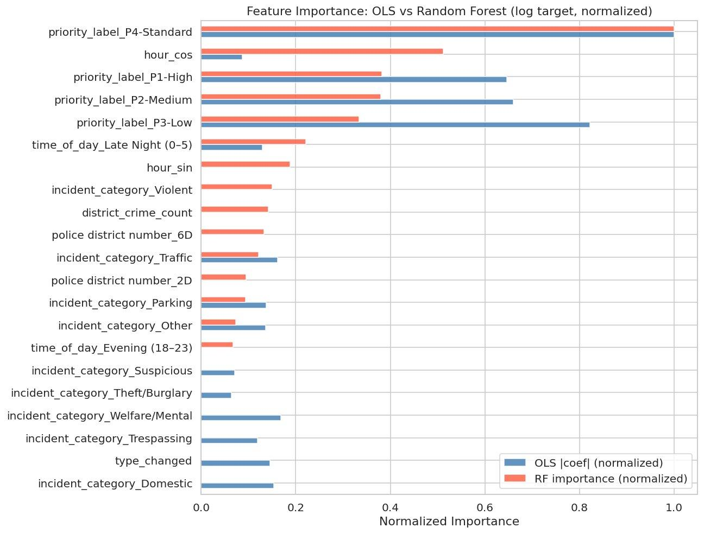
Figure 5. Normalized feature importance: OLS absolute coefficients (blue) vs. Random Forest permutation importance (orange), log target. Both models agree that priority dominates all other predictors.
Figure 5 confirms that priority level is the dominant predictor across both modeling approaches. P4-Standard alone accounts for the largest importance score in both models by a wide margin. Both methods identify hour_cos (cyclic time encoding) as the next most important feature, followed by priority labels P1–P3. The strong agreement between OLS and Random Forest on feature rankings validates the findings; when two methods with different assumptions agree, the finding is robust.
The modest R² values across all specifications (maximum 0.124) are expected rather than indicative of model failure. Response time has high inherent variability driven by unobserved real-time factors, officer location at time of call, concurrent call volume per district, and live traffic conditions, none of which are captured in this dataset. The models identify the structural predictors of response time; the remaining variance reflects operational randomness not described by this dataset.

6. Conclusions & Recommendations
This analysis demonstrates that dispatch response time in Montgomery County is primarily determined by three structural factors: priority level, geographic district, and time of day. Priority is the dominant predictor by a substantial margin, consistent with the design of the dispatch system. However, several findings have direct policy implications:
- P1-High and P2-Medium receive statistically identical response times, suggesting the two-level distinction may not translate to operational practice. A review of dispatch protocol by MCPD for these priority levels is warranted.
- Districts 3D and 6D consistently achieve the fastest response times despite high crime volumes, suggesting effective deployment strategies in those areas that could inform resource allocation in slower districts.
- The 59,011 calls (23.4%) with no recorded officer arrival represent an understudied population. Understanding what proportion of these represent cancelled calls, self-resolved incidents, or data recording failures has implications for both operational efficiency and outcome measurement.
- Extending the dataset to include concurrent call volume per district at the time of the incident would likely explain a substantial portion of the unexplained variance and improve model utility for operational forecasting.

Future work should incorporate beat and PRA-level geographic analysis (finer resolution than district), gradient boosting models for potentially stronger predictive performance, and a full multi-year dataset to capture seasonal variation. An interactive dashboard visualizing response time patterns by district, priority, and hour would make these findings accessible to operational decision-makers.

References & Resources
Montgomery County Department of Police. (2025). Police Dispatched Incidents.
Data Montgomery Open Data Portal.
https://data.montgomerycountymd.gov

Montgomery County Department of Police. (2025). Crime Reports.
Data Montgomery Open Data Portal.
https://data.montgomerycountymd.gov

